Half Adder Symbol
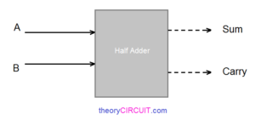
The Half adder will take two inputs Named as A, B then it will give two outputs named as Sum, Carry.
- Sum = A ⊕ B
- Carry = A . B

Half Adder Logic Gate diagram
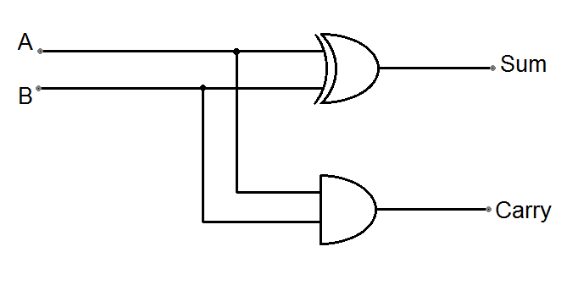

Two input XOR gate, two input AND gate forms the Half Adder logic circuit. Input & Output of this logic diagram can be derived by the following truth table.
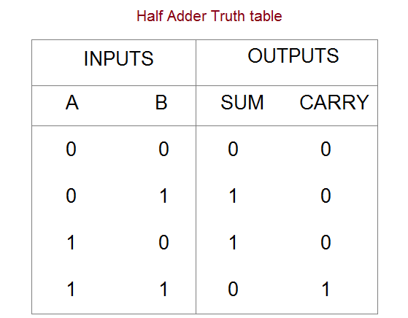

When both inputs are low then sum and carry will be logic low (0),
If any one input is high then Sum will be logic high (1) and carry will be logic low (0).
When both inputs are high then Sum becomes logic low (0) and Carry becomes logic high (1).

